Final Project Design Phase
Computer Science - Week 11
Oct 3, 2026 - Version 0.0.4

For complete instructions and project ideas, refer to the assignment in Canvas. Specifically, review the final project requirements before you continue below. If you have not reviewed the project requirements in Canvas (you might have to go to the modules view and check the current or past week's content), you will not be able to properly complete the parts below. In addition, it may be helpful to review the information on this Drafter documentation page.

0) Project Planning and Preparation
Successful programmers spend time planning before they begin coding. After reviewing the project requirements, answer the following questions to help guide your design and development process.
- What concepts from class or previous assignments might help you complete this project? Which programming concepts (loops, conditionals, lists, classes, etc.) do you expect to use? What programming skills do you want to improve while completing this project?
The route and dataclass concepts will help along with using loops and if statements. I want to improve my loop skills since I struggle with that.

- Which parts of the project do you expect to be the easiest for you? The hardest? Why?
The easiest will be to write the dataclasses. Dataclasses are simple to me and I understand them well. The hardest will be all of the loops because they are tricky to me.

- Even though you have not yet designed the final project, estimate which tasks will likely require the most time and effort? Which features or components should be implemented first?
The most time and effort will be creating all of the routes and data classes. I want to try to do this all first then make my website look cool.

- What distractions might interfere with your work and how will you minimize them? What resources will you need available while working? What questions, if any, do you still have about the assignment requirements?
Distractions will be to go on my phone, but I will put my phone away while I work on this to get it done.

1) Site Diagram
Create a mock-up of your planned website. We suggest you make the mockup on paper, although you can also use software like PowerPoint or Slides to make a mockup. There is other design software that could also be used, but we strongly encourage you to keep it simple. Do not spend more than 15-30 minutes detailing the mock-up. Your goal should be to make a very quick and dirty diagram, to show that you have some kind of idea.

We recommend drawing each page as a rectangle, and laying out the text, buttons, and other components inside. Then, use arrows to indicate links between pages. Label each page the way you will name each function, and then put labels on the arrows to indicate what the button links. Also write down any parameters that should come into the pages.

In addition to the pages and routes, write down what fields your `State` will have, both their names and types. Think clearly about what data will need to be persistent across the entire website.

Add photo(s) or screenshot(s) of your website mock-up and labeled diagram on the next page.
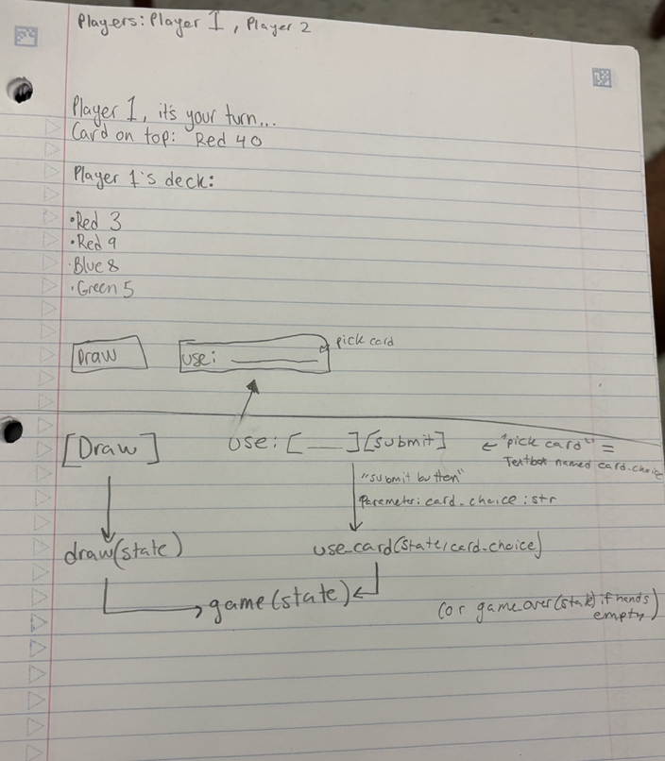

2) Implementing Requirements
This table should serve as a draft for how you will implement the requirements into your final project. You may change your ideas later on, but your final site must fulfill all the requirements.

Requirement | Implementation
Purpose/Functionality  A 1-2 sentence description of the purpose or functionality of your site | Our site is a simplified uno game that 2 players play on one computer. Each player will take their turn until their pile of cards runs out.
State Dataclass Attributes  Minimum of 4 attributes, one of which must be a list/dict of instances of your second dataclass.  Briefly describe each attribute, its type, and how it will be meaningfully modified throughout the site. | - Player_1: str, name of the first player and their deck  - Player_2:str, name of player and their deck  - Draw_pile:list[Card], stores cards available to draw  - Discard_pile: list[Card], stores cards that were played by the players  - Current player: int, tracks whose turn it is and moves it to the next person after a valid action.
Second Dataclass  Your second dataclass, including its attributes, their types, and how they will be meaningfully modified (if they are modified) | Card:  Color - str, the cards color  Value- str, cards number
Routes (minimum 7)  The names of your route functions | - Index - home page with links to either start the game or read the rules  - Set_up page - asks for players names  - Start_game - creates/ shuffles cards and hands them out to players to then start the game  - Game_page - shows current turn, the top card, and the players deck  - Play_card - plays the selected cards and see if it works, if not an error will happen and you need to try another move  - Draw_card - gives the current player a card when they cannot make a move within their deck  - Rules_page - explains the rules of the game  - Winner_page - tells you who won the game  - Reset_game - starts the game over so you can play again
Pages (minimum 5)  A brief description of the pages in your site | - Home page - introduces the game and shows the buttons to play or read the rules  - Setup page - collects the two players names that they typed in  - Game page - shows whose turn it is, the deck, and the players hand  - Rules page - shows the rules of the game  - Winner page - shows which player won the game of UNO
User Input (minimum 3)  Description of user input components (TextBox, TextArea, CheckBox, or SelectBox) and their purposes  For more information on these input types, see Drafter Documentation. | - TextBox for Player 1 name - an area to type out player 1’s name  - TextBox for Player 2 name - an area to type out player 2’s name  - SelectBox - on the game page so the current player can choose which can they want to play in their hand
If Statements (minimum 3)  Brief description of what will be evaluated in your if statements and how they will meaningfully change the logic of the site | - If card_choice != player.card it will send an error and go back to the game, this will prevent using cards that do not match or follow the rules  - If card.number != top_card.number and card.color != top_card.color then it will produce an error because the player has no available cards that match the top card, forcing them back to the game and to draw a card  - If len(player.cards)==0, then the game ends and that player wins the game, because they ran out of cards
Loop (minimum 1)  This loop must iterate over the list/dict of dataclass instances in your State attribute.  Description of this loop and why it is meaningful to the site | The game will use a loop to iterate through the current player’s list of Card objects and show each card as an option to play. This is meaningful because the number of cards in the players hand cfhanges as the cards are drawn and played by the player, so the website needs to display the current list each turn.

LLM Conversation
If you used an LLM in any part of this work, copy and paste every part of that conversation below. Otherwise, you may be given a zero for the assignment. Obviously, these words will not all be yours, and this is the exception to the requirement at the top of this assignment that all responses be in your own words. If you did not use an LLM to assist you in this assignment, simply say so below.
Me: for my project can you help me come with some dataclass and route ideas
Chat: Absolutely. For your simplified UNO Drafter website, I would keep the dataclasses and routes simple so they are manageable for a first-year computer science project. Here are some ideas. 1. Dataclass ideas You need at least two dataclasses: one for State and another for your game objects. Card Dataclass - Color: Stores the card's color (red, blue, green, or yellow). - Number: Stores the card's number (0–9). Player Dataclass - Name: Stores the player's name. - Cards: Stores the cards in their hand. - Score: Keeps track of their score. State Dataclass - Players: Stores both players. - Draw pile: Stores cards that haven't been played. - Discard pile: Stores cards that have been played. - Current player: Tracks whose turn it is. - Message: Displays game updates. - Game over: Tracks whether the game has ended.Your assignment requires at least seven routes. Here are nine ideas. Route Purpose index Home page setup_game Enter player names start_game Create cards and deal hands game_page Display the current game play_card Play a selected card draw_card Draw a card rules_page Explain game rules winner_page Display the winner reset_game Restart the game. Here is the basic website layout: 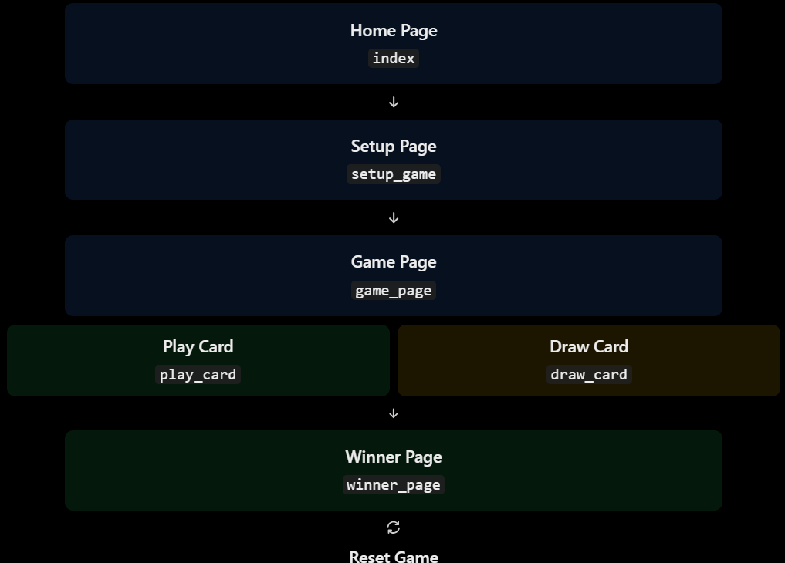

Final Submission
When you are finished, download this file as a Word Document (docx) and upload the file to the appropriate assignment on Canvas.

